**CW1**

**Introduction**

I have received a task from my client Hamza Ali from an online clothing fashion company, to create an app. The app that I am going to be designing is called “ShoePendium“. The name has been chosen relevant to the target audience in order to maximise attractivity of the name. The target audience has a wide range of people, it goes from 12 year olds up to 60 year old people. The purpose of this project is to design an app which will allow customers to buy online as well as participate in incentives and other marketing promotions. In order to identify the best audience and most-suited design for the users, I have researched other professional clothing applications including JD Sports, Footlocker and FootAsylum as they have been in the market for a long time and have a fixed audience and experience as well. This means that after looking at these applications, I should be able to create a professional new software application which will be professional.

**Research**

My inspiration for the design of the website/app or concept of ShoePendium has been found in “FootAsylum” and “Schuh” which are well known Shoe & Clothing companies which have been established for years in the business so they have a lot of experience. This means that when I look at their websites/software, I see pure professionalism. Throughout my research journey, I gained insights of the current trends, the target audience and consumer preferences as well as being able to have a look at what materials are the most popular within the designated target audience. Additionally, to the factors affecting the target audience, I also researched their software & websites for digital factors that make the software/websites look more appealing and improve the user experience. Therefore, I created a design based on this research.

**Moodboards**

**1:**

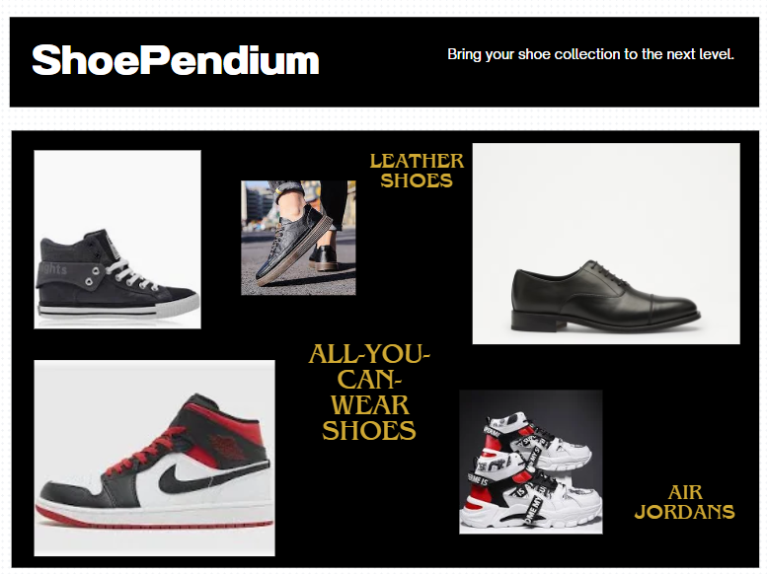

**2:**

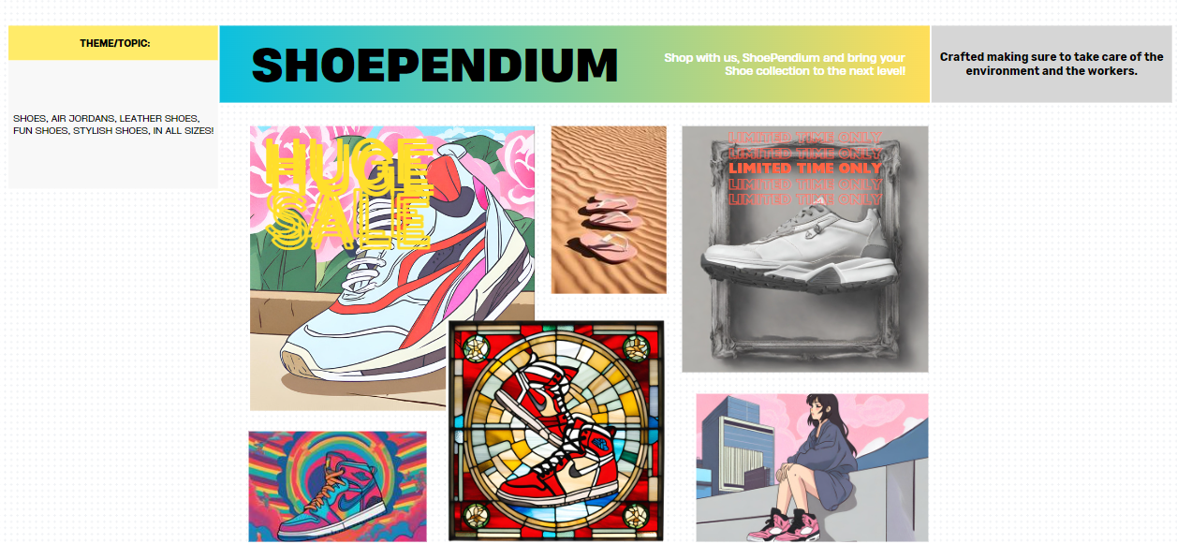

**3:**

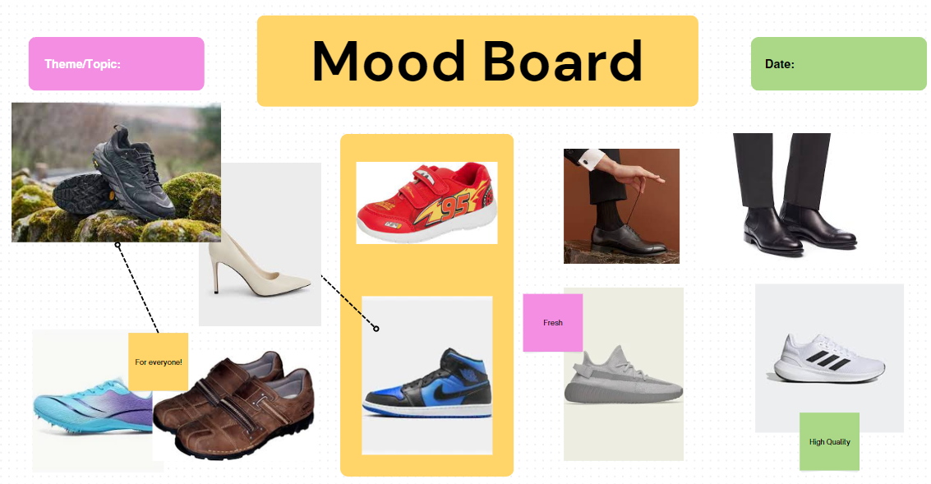

**Persona Cards:**

**Client:**



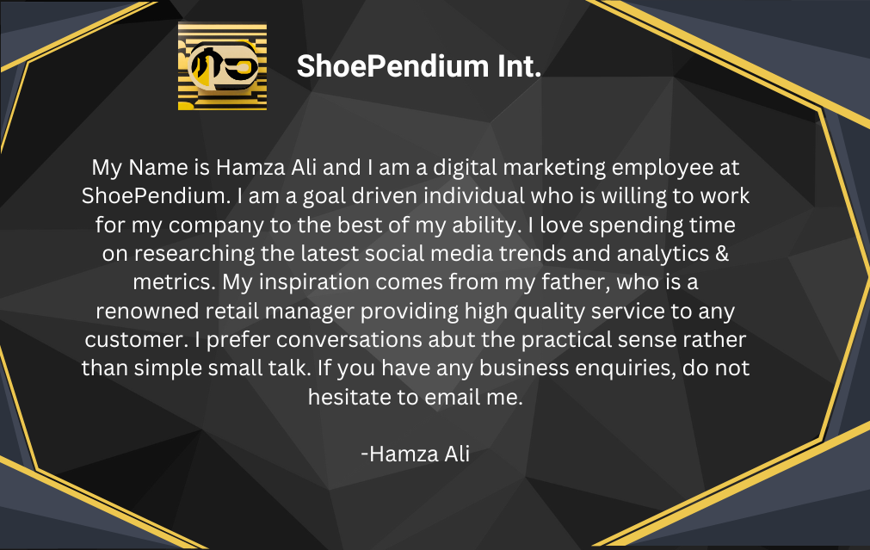

**User:**

**1:**

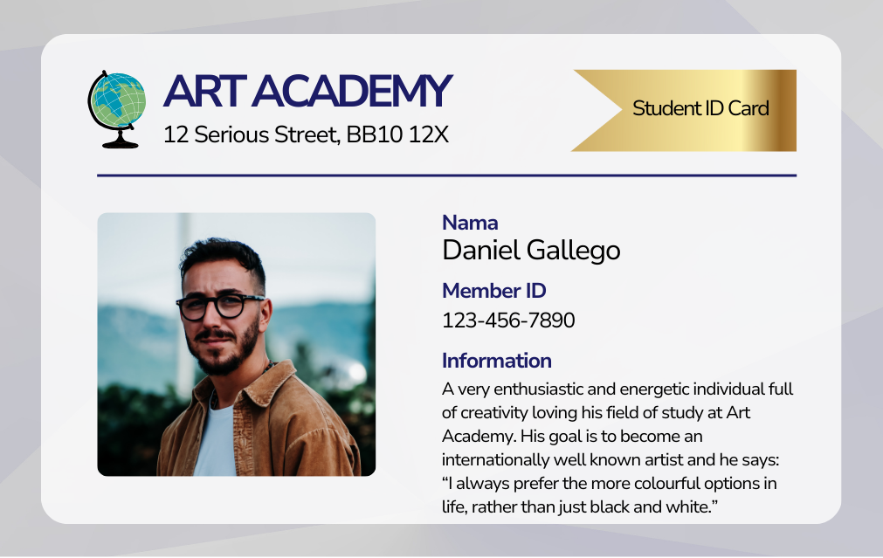

**2:**

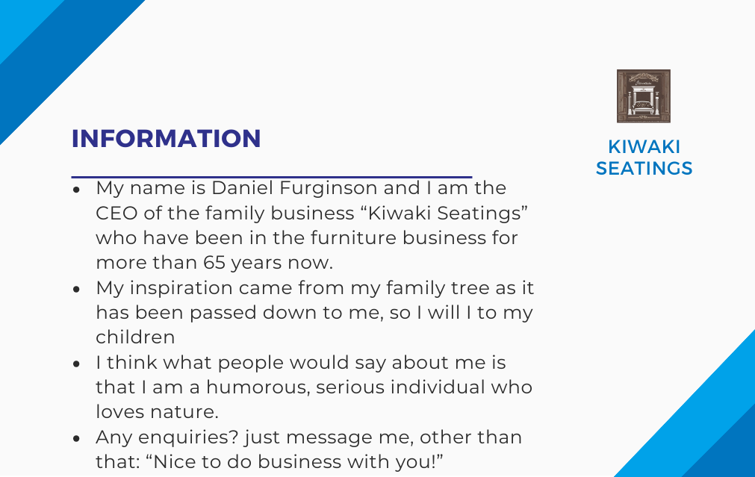

**The User Story:**

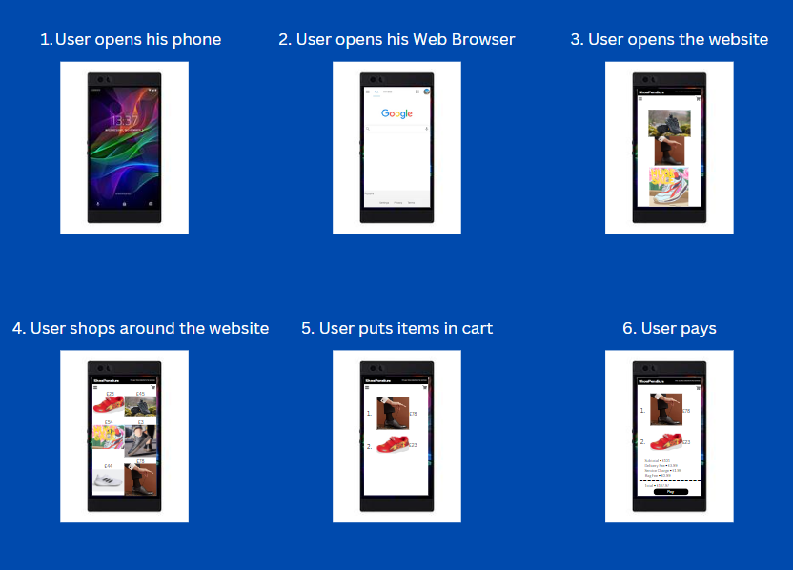

**User Journey Map:**

**1:**

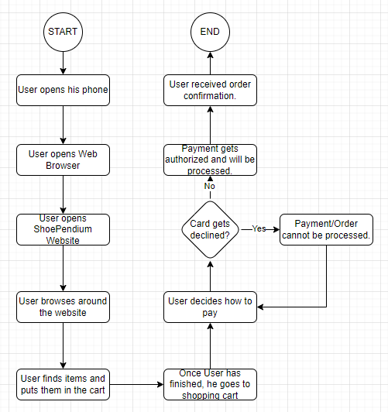

**2:**

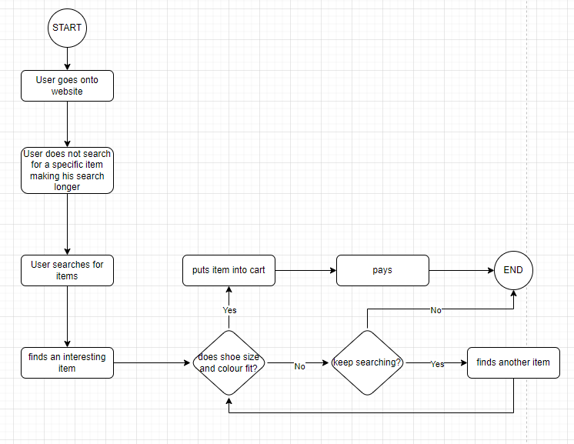

**Designs:**

**Low Fidelity:**

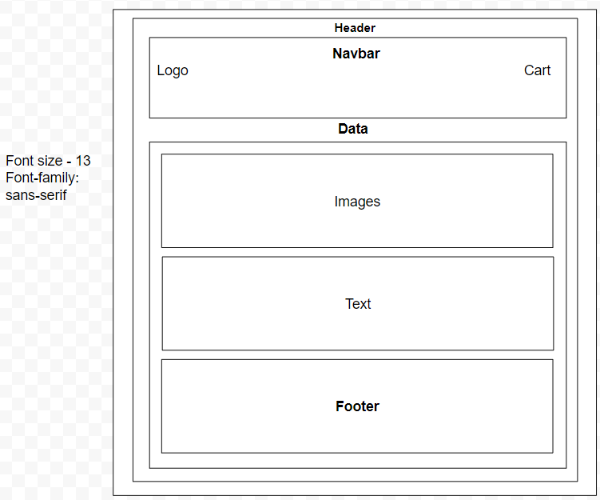

**High Fidelity:**

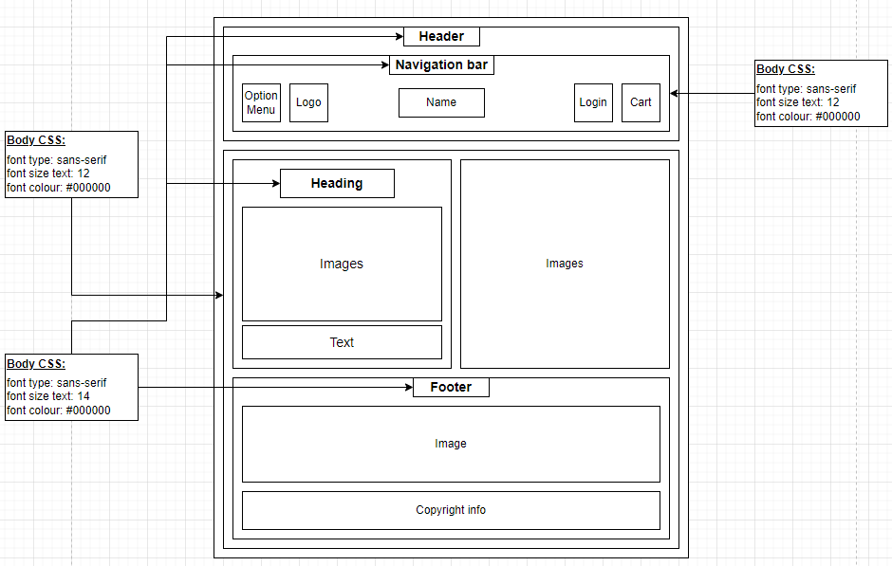

**Evaluation**

First of all, the purpose of this project was to not only create a design for the client but also to develop a variety of skills. A range of these skills include: User experience design, Communicating with the client, creativity, Software design and attention to detail. The targeted audience are people from 12 years to 60 years, this will give a broader shopping audience the opportunity to shop from ShoePendium as it has shoes for people from the most ages. The origin of the name ShoePendium started with getting together two words that make sense and combine what the website offers as well as being able to show the customers who shop on the website that there is a lot of variety and selection of Shoes. Speaking of the origin, the idea behind the design of ShoePendium were two large shoe and clothing companies: “FootAsylum” who is offering shoes as well as other clothing pieces, however mainly focusing on shoes, whilst the other company: “Schuh” is all about shoes. “FootAsylum” is targeted at a younger audience whereas “Schuh” is focused on every age which makes it easy to have a look at how to create the “ShoePendium” website & design when combining these two company ideas into one. My strength in this whole project was the high fidelity wireframe, this is because I already have a quite a bit of experience when it comes to creating wireframes due to my Web development courses from which I have gained not just the skills to develop and design websites but also to create low as well as high fidelity websites. Another important aspect of my strengths within this project is the creation of the Moodboards as I can be creative when it comes to collecting ideas/different images together into one image or board. Additionally, time management was also a strong factor, not just because the Journal log has helped me take track of what I have done during the past few weeks but also what I can do during the upcoming weeks and how it would fit into my schedule. Considering weaknesses, my main weakness during this project was creating the User story as I was not sure how bring my website onto the size of a phone display as it has been originally designed for desktop, however if the design is supposed to be successful, then there is also a strong need for a phone design therefore I was able to practise resizing your website.

There were not really any limitations except that I was not able to use Photoshop as Photoshop is the most useful tool when it comes to creating, altering and designing images. With that kept in mind, when using photoshop, there would have been more possibilities in terms of changing the size of images or creating improved mood boards, persona cards etc. Other than that, I did not have any limitations in terms of devices and software. This whole project has raised so many opportunities to increase the knowledge of UX & different skills that are being used in the digital world nowadays. On the other hand, this project has also raised opportunities that could have been made, including: a more detailed research to increase the research capability of myself. Additionally, photo editing could have been practised more to create even better and more stunning images regardless of Photoshop as there are alternatives to Photoshop. Communication could have been implied more severely as it is a crucial part of the development process of the project and me in terms of receiving feedback, reflecting on the given feedback and then working on that feedback to bring it into the project.

In conclusion, consider the inspiration for the design of this project where the sources are established shoe and clothing companies: “FootAsylum” & “Schuh”, which are very professional and have a lot of market experience due to their many years of existence. Current trends and consumer preferences have also been taken into consideration, insights were gained and gathered regarding the current trends, target audience as well as popular materials and shoes within the target audience. Research also included the analysis of factors that will enhance the user experience of software and website and based on the research of the insights, a design for the app was created whilst making sure to meet the needs and preferences of the target audience. I think that this project was a complete success in terms of development and collecting knowledge. This is because I have been able to practise a variety of different skills that I have learned during the past few years. Furthermore, different aspects could be met, client requirements as well as client satisfaction by ensuring that the final designs meet the client’s expectations and requirements. The user experience by assessing the app’s usability and gathering feedback to improve it, to maintain professional standards by using the evaluation to compare & review the final product against the industry & the effectiveness on the market by how well and efficient the app performs in supporting the marketing promotions to make sure the business grows, by promoting the business, it does not only grow but the users are also engaged effectively. Everything has been considered in order to create and then also maintain a high-quality project that meets the client as well as user requirements. One lesson that I have learnt was that communication is very important as it improves your work due to the given feedback on which you are able to reflect on. Another lesson is visual perception, if you wouldn’t buy or buy from your own product, then it is not likely to perform well. Additionally, documentation is underrated as it keeps everything together. For example, I have created a critical journey in which I reflect on my work and keep track of everything that I have done which will help in improving my overall performance and work.